**CIS L1 Benchmark Hardening Plan**

For CIS hardening we need to follow the following steps:  
1. Login to CIS Workbench and search the hardening kit for the particular server.

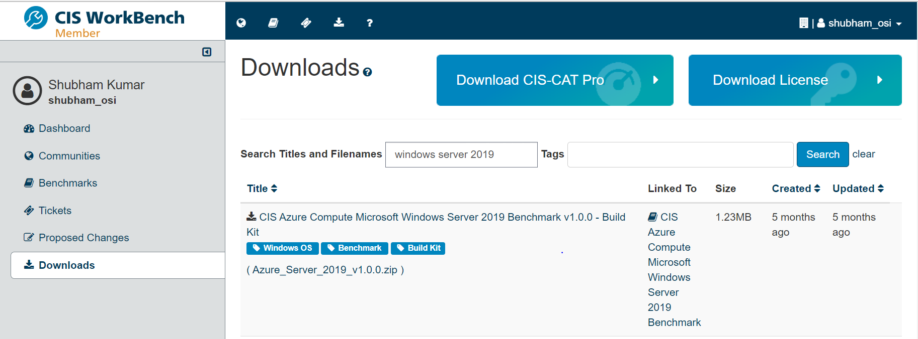

2. After downloading the kit in the server unzip it.

3.Now download lgpo utility to import the GPO.

[Download Microsoft Security Compliance Toolkit 1.0 from Official Microsoft Download Center](https://www.microsoft.com/en-us/download/details.aspx?id=55319)

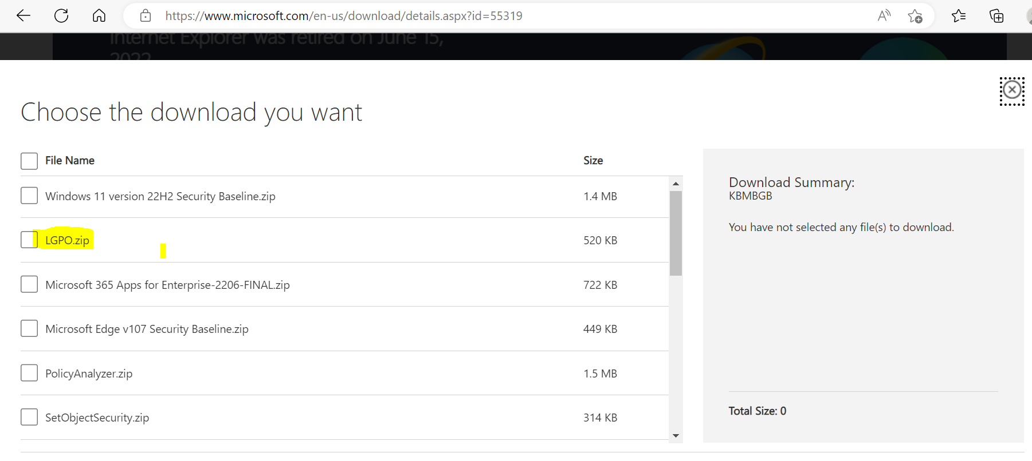

4. Now unzip the lgpo.

5.Now open command prompt in administrative mode and run the following commands.

C:\CIS\Windows\lgpo.exe /q /g “C:\CIS\Windows\Server2016STIGv1.0.0\MS-L1\{898B400C-901F-4809-9F04-631305853570}”}

Reference: [How to deploy CIS hardening scripts on Windows VM hosted in the Azure - Dan Djurasovic Blog](https://blog.djurasovic.com/how-to-deploy-cis-hardening-scripts-on-windows-vm-hosted-in-the-azure/)

6. Once GPO is imported we need to reboot the server.